DAY 15
Q29: Write a program to calculate the factorial of a number.
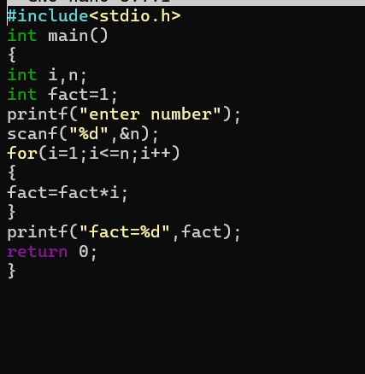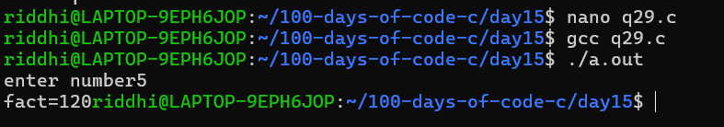

Q30: Write a program to reverse a given number.

